Instructions for Preparation of Papers for HEIC2025 Conference, Dubrovnik, Croatia
Author One¹, Author Two² and Author Three³
¹Name of Institution, City, Country, email of Author One
²Name of Institution, City, Country, email of Author Two
³Name of Institution, City, Country, email of Author Three

Abstract
Use the Italics for the abstract text. The abstract should be 150-200 words. Do not change the fonts, margins or line spacing settings of this paper template. The paper in its all entirety may NOT be longer than 8 pages. The abstract should consist of a concise summary of the material discussed in the paper. It is preferable not to use footnotes in the abstract or the title. Do not cite references in the Abstract. Avoid using abbreviations in the Abstract. The abstract should be contained within one paragraph. Keywords are also written in Italics. It is recommended not to give more than six keywords, separated by commas. We wish you success with the preparation of your manuscript.

Keywords: Keyword 1, Keyword 2, Keyword 3.

1. Introduction
Use the Heading 1 style for first level section headings. The first level section headings are typed in Calibri, bold, 14 pt. Use the Normal style for paragraph text. Papers must be typed in English using MS-Word only. This instruction page is an example of the format and font sizes to be used.
The title of the paper is typed in Calibri, bold, 20 pt and centred on the page. The author listing is typed in bold letters and centred on the page (Times New Roman, 10 pt). Use the full first name and surname for the authors. Directly under the author listing and also entered are the authors’ affiliations and e-mails (Times New Roman, 10 pt, italic). If authors belong to more than one institution, marks/numbers should be used to establish the correspondence. Give the institution, city, country and e-mail of every author. If an author is submitting more than one paper please provide the same name in all papers.
Manuscripts must be typed single spaced using 10 point characters and be formatted for A4 size paper (297x210 mm). Only Times New Roman fonts are accepted for the text. Page should have top margin of 3.0 cm, bottom margin of 4.0 cm, left and right margins of 2.54 cm (1 inch). The text of the papers is written in one column and justified. The maximum length of your paper should be 8 pages including references, tables and figures. The paper should be written in Standard English.

1.1. Section Headings
Use the Heading 2 style for second level headings. The second level headings are typed in Calibri, bold, italic, 12 pt. The headings are aligned to the left.

1.2. Separation of Paragraphs and Indentation
Paragraphs are separated by 6 pt after a paragraph, and only the first paragraph of every new heading is without the indention – the rest of the paragraphs of the same heading are with an indent of 0.5 cm.

1.3. References
Place references in separate section at the end of the document – 9pt left aligned. Do not footnote references. Refer simply to the reference number, as [1] or [2]-[4]. Type references on a list in sequence in the order cited in the paper. There are examples of formats for different kind of citations in the end of this template. [5, 6]

2. Figures and tables
Figures and tables should be centred in the column and numbered consecutively throughout the text. Figures should have a caption underneath (see for example Figure 1) while the caption for tables should be above. Figure style and table style captions are Times New Roman, 10 pt. Content inside of the table should be in Times New Roman, 9 pt.

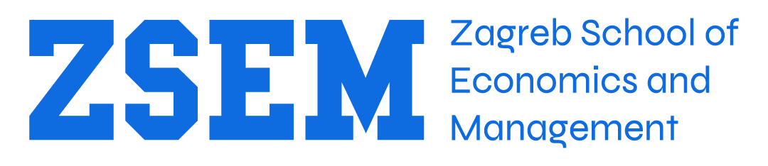

Figure 1. Logo of ZSEM. This is an example of a figure caption.

All figures and tables should be included in the electronic versions of the full paper. Leave one blank line above and below each Table or Figure.

3. Headers and Footers
No headers are allowed.
Footer text should be Times New Roman, 8 pt.

4. Quality of the paper
It is important that your paper shows clear connection to higher education and is useful to educators.
All papers will be double-blind peer reviewed. The review form includes the following topics:
- Contents (e.g.: clarity of objectives; basis of theory; conclusions drawn; understanding of subject; etc.)
- Degree of Novelty or Originality (e.g.: presence of new ideas; innovative contributions; whether bulk of materials has been published elsewhere; etc.)
- Structure of Paper (e.g.: general layout; use and proper numbering of figures/diagrams; etc.)
- Quality of Text (e.g.: clarity of expression; consistency; readability; number of quotations and references; etc.)
- Reviewer's General Opinion and Comments (e.g.: correctness of text; applicability of the items included; quality of paper; scope covered; etc.).

Every paper contains an abstract, keywords and an introduction. This is usually followed by related theory/literature, methodology and results, conclusion and discussion, acknowledgements and references.

5. Conclusion
You are able to use this template so that you type over sections by using cut and paste into it, and/or use the given styles. To use the built-in styles, highlight a section that you want to designate with a certain style, then select the appropriate name on the style menu.

6. Acknowledgements
The acknowledgement for funding organizations etc. should be placed in a separate section at the end of the text.

References
- K. Aleksic-Maslac, B. Sinkovic and P. Vranesic, “Influence of gamification on student engagement in education”, International Journal of Education and Learning Systems, Volume 2, pg. 76-82, 2017.
- S. Krunić and S. Lugović, “Supporting education and learning with game design elements”, Proceedings of 19th International Conference on Engineering Education, Zagreb, 2015., pg. 636-643.
- K. Aleksić-Maslać, B. Sinković and P. Vranešić, "Influence of Gamification on Student Engagement on a Course - Information and Communication Technologies“, WSEAS Transactions on Advances in Engineering Education, Volume 14, 2017, E-ISSN: 2224-3410, pg. 113-122.
- L. Da Rocha Seixas, A. S. Gomez and I.J. de Melo Filho, “Effectiveness of Gamification in the Engagement of Students”, Computers in Human Behavior, 58, pg. 48-63, 2016.
- K. Aleksic-Maslac and M. Magzan, “ICT as a tool for building social capital in higher education”, Campus-Wide Information Systems, ISSN: 1065-0741, Volume: 29 Issue: 4, 2012.
- M. D. Hanus, J. Fox, “Assessing the effects of gamification in the classroom: A longitudinal study on motivation, satisfaction, effort and grades”, Computers & Education, 80, pg. 152-161, 2015.

